1. PRE-PROCESS THE DATASET:

The dataset consists of negative values. So we have normalized the dataset by making all the value between 0 and 1. For ease of use and data modelling, the target class values have been replaced. “g” is replaced with “1” and “b” is replaced with “0”. After normalization column 2 values changes to NaN. We replaced it with the original values i.e. 0,

**Code**: install.packages("caret")

library(caret)

install.packages("RANN")

library(RANN)

ionosphere <- read.csv("http://archive.ics.uci.edu/ml/machine-learning-databases/ionosphere/ionosphere.data", header=FALSE)

ionosphere$V35 <- ifelse(ionosphere$V35 == "g", 1, ifelse(ionosphere$V35 == "b", 0, ""))

maxs = apply(ionosphere, MARGIN = 2, max)

mins = apply(ionosphere, MARGIN = 2, min)

scaled = as.data.frame(scale(ionosphere, center = mins, scale = maxs - mins))

scaled[is.na(scaled)] <- 0

**Co-relating variables in dataset:**

install.packages("corrplot", dependencies = TRUE)

library(corrplot)

M <- cor(scaled)

corrplot(M, method="circle")

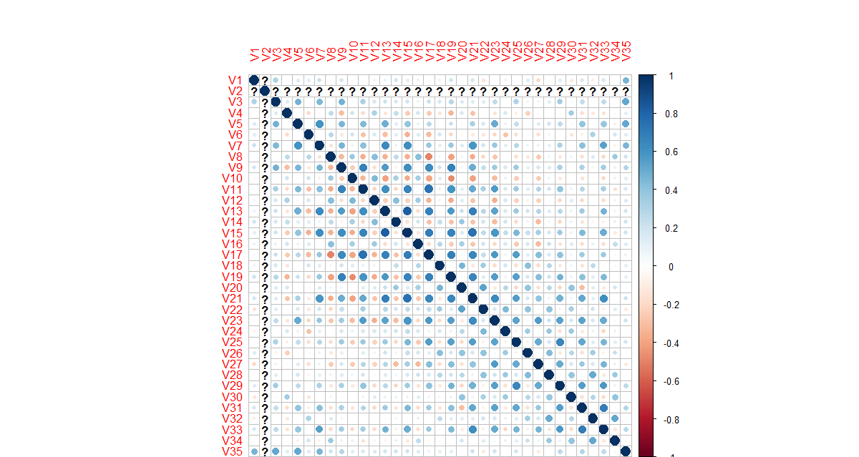

**Co-relation between the attributes**

